**EFFECTIVE HEART DISEASE PREDICTION USING IBM AUTO AI SERVICE**

S.Karthika, Bannari Amman Institute of Technology, Sathyamangalam.

Mail id: karthikas@bitsathy.ac.in

**1. INTRODUCTION**

* 1. OVERVIEW

Coronary illness portrays a scope of conditions that influence your heart. Sicknesses under the coronary illness umbrella incorporate vein infections, like coronary supply route sickness, heart beat issues (arrhythmias) and heart abandons you're brought into the world with (inborn heart deserts), among others. The expression "coronary illness" is frequently utilized conversely with the expression "cardiovascular infection". Cardiovascular sickness by and large alludes to conditions that include restricted or impeded veins that can prompt a coronary failure, chest torment (angina) or stroke. Other heart conditions, like those that influence your heart's muscle, valves or musicality, additionally are viewed as types of coronary illness.

Coronary illness is one of the greatest reasons for dismalness and mortality among the number of inhabitants on the planet. Forecast of cardiovascular sickness is viewed as perhaps of the main subject in the segment of clinical information examination. How much information in the medical services industry is gigantic? Information mining transforms the enormous assortment of crude medical care information into data that can assist with settling on informed choices and expectations.

This makes coronary illness a main pressing issue to be managed. However, it is challenging to recognize coronary illness on account of a few contributory gamble factors, for example, diabetes, hypertension, elevated cholesterol, strange heartbeat rate, and numerous different variables. Because of such limitations, researchers have turned towards present day approaches like Data Mining and Machine Learning for anticipating the sickness.

1.2 PURPOSE OF THE PROJECT

AI ends up being successful in helping with simply deciding and forecasts from the enormous amount of information created by the medical care industry.

**2. LITERATURE SURVEY**

There is number of works has been done related to disease prediction systems using different algorithms in medical Centers.

**[1] Senthilkumar Mohan, Chandrasegar Thirumalai, Gautam Srivastava, Effective Heart Disease Prediction Using Hybrid Machine Learning Techniques, Digital Object Identifier 10.1109/ACCESS.2019.2923707, IEEE Access, VOLUME 7, 2019.**

Effective Heart Disease Prediction Using Hybrid Machine Learning Techniques in which strategy that objective is to finding critical includes by applying Machine Learning bringing about improving the exactness in the expectation of cardiovascular malady. The expectation model is created with various blends of highlights and a few known arrangement strategies. We produce an improved exhibition level with a precision level of 88.7% through the prediction model for heart disease with hybrid random forest with a linear model (HRFLM) they likewise educated about Diverse data mining approaches and expectation techniques, Such as, KNN, LR, SVM, NN, and Vote have been fairly famous of late to distinguish and predict heart disease.

**[2] Avinash Golande, Pavan Kumar T, Heart Disease Prediction Using Effective Machine Learning Techniques, International Journal of Recent Technology and Engineering (IJRTE) ISN: 2277-3878, Volume-8, Issue-1S4, June 2019.**

Heart Disease Prediction Using Effective Machine Learning Techniques in which Specialists utilize a few data mining strategies that are available to support the authorities or doctors distinguish the heart disease. Usually utilized methodology utilized are decision tree, k- closest and Naive Bayes. Other unique characterization-based strategies utilized are packing calculation, Part thickness, consecutive negligible streamlining and neural systems, straight Kernel self- arranging guide and SVM (Bolster Vector Machine). The following area obviously gives subtleties of systems that were utilized in the examination.

2.1 EXISTING SYSTEM

The current arrangement of this venture is anticipating the sickness in KNN Algorithms, Decision Trees Algorithms, and Naive Bayes Techniques. This framework involves 13 clinical qualities as information and with that information, Data sets it to handle the information mining methods and shows the most dependable one. The potential outcomes of happening coronary illness of the patients with regards to rate. This is performed through information mining characterization strategies.

2.2 PROPOSED SYSTEM

The proposed system of the project is used to predict heart disease using IBM Auto AI Service. The Auto AI graphical tool in Watson Studio analyzes your data and discovers data transformations, algorithms, and parameter settings that work best for your predictive modeling problem. Auto AI displays the results as model candidate pipelines ranked on a leaderboard for you to choose from.

**Data format**: CSV files, with comma (,) delimiter for all types of Auto AI experiments.

**3. THEORITICAL ANALYSIS**

**3.1 BLOCK DIAGRAM**

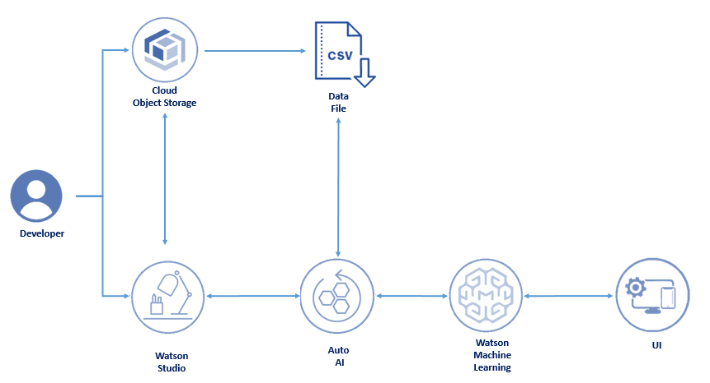

**3.2 HARDWARE DESIGN:**

* System            : Pentium Dual Core.
* Hard Disk       : 120 GB.
* Monitor          : 15’’ LED
* Input Devices : Keyboard, Mouse
* Ram                : 1 GB

**SOFTWARE DESIGN:**

* Operating system: Windows 7, 10.
* Coding Language : Python

**Category: IBM Cloud Application**

**Skills:**   
IBM Cloud,

IBM Watson,

Node- RED,

IBM Machine Learning,

IBM Cloud Object Storage

**4. EXPERIMENTAL INVESTIGATIONS**

Cardiovascular sicknesses (CVDs) are the number 1 reason for death universally, taking an expected 17.9 million lives every year, which represents 31% of all passing’s around the world.

Cardiovascular breakdown is a typical occasion brought about by CVDs and this dataset contains 9 elements that can be utilized to foresee mortality by cardiovascular breakdown.

In this task, you want to fabricate a model utilizing Auto AI and construct a web application where we can feature the expectation of cardiovascular breakdown.

**Services Used:**

* IBM Watson Studio
* IBM Watson Machine Learning
* Node-RED
* IBM Cloud Object Storage

**5. FLOW CHART**

Watson Studio Create

Project (Heart Disease Prediction)

Auto AI

Create the Model, Add Dataset for Heart Disease Prediction

Deploy the model (Heart Disease Prediction)

Node-RED Service

Build an application using Node-RED Service

Prediction on UI (Heart Disease)

**6. RESULT**

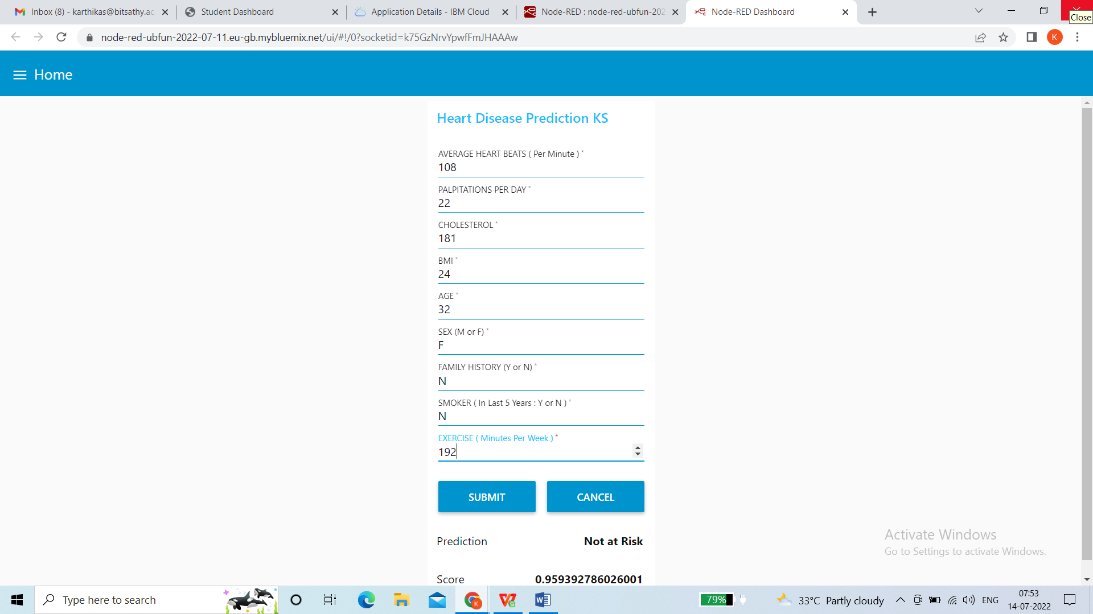

**7. ADVANTAGES AND DISADVANTAGES**

Advantages:

* Data preparation and ingestion
* Feature engineering (Feature selection, Feature extraction)
* Model selection

Disadvantages:

* Make Humans Lazy
* Increase in Unemployment

**8. APPLICATIONS**

* Product research and development
* Healthcare
* Supply chain
* Distribution
* Sales and customer service
* Marketing

**9. CONCLUSION**

The strategy of heart disease Prediction concluded using IBM Auto AI Service. The proposed arrangement of the task is utilized to anticipate coronary illness utilizing Using IBM Auto AI Service. The Auto AI graphical apparatus in Watson Studio examines your information and finds information changes, calculations, and boundary settings that turn out best for your prescient demonstrating issue. Auto AI shows the outcomes as model competitor pipelines positioned on a list of competitors for you to look over. The NODE-red plays a vital role in performing the prediction of heart disease using json file.

**10. FUTURE SCOPE**

In future a savvy framework might be fostered that can prompt choice of legitimate treatment strategies for a patient determined to have coronary illness. A ton of work has been done currently in creating models that can foresee whether a patient is probably going to create coronary illness or not. There are a few treatment strategies for a patient once analyzed with a specific type of coronary illness. Information mining can be of awesome assistance in choosing the line of treatment to be trailed by separating information from such reasonable data sets.

**11. BIBILOGRAPHY**

[1] American Heart Association, Classes of Heart Failure, American Heart Association, Chicago, IL, USA, 2020, [https://](https://www.heart.org/en/health-topics/heart-failure/what-is-heart-failure/classes-of-heart-failure) [www.heart.org/en/health-topics/heart-failure/what-is-heart-](https://www.heart.org/en/health-topics/heart-failure/what-is-heart-failure/classes-of-heart-failure) [failure/classes-of-heart-failure.](https://www.heart.org/en/health-topics/heart-failure/what-is-heart-failure/classes-of-heart-failure)

[2] Senthilkumar Mohan, Chandrasegar Thirumalai, Gautam Srivastava, Effective Heart Disease Prediction Using Hybrid Machine Learning Techniques, Digital Object Identifier 10.1109/ACCESS.2019.2923707, IEEE Access, VOLUME 7, 2019.

[3] Avinash Golande, Pavan Kumar T, Heart Disease Prediction Using Effective Machine Learning Techniques, International Journal of Recent Technology and Engineering (IJRTE) ISN: 2277-3878, Volume-8, Issue-1S4, June 2019.

[4] S. Marsland, “Machine learning,” An Algorithmic Perspective, CRC Press, Boca Raton, FL, USA, 2020.

[5] P. Melillo, N. De Luca, M. Bracale, and L. Pecchia, “Classi- ﬁcation tree for risk assessment in patients suﬀering from congestive heart failure via long-term heart rate variability,” IEEE Journal of Biomedical and Health Informatics, vol. 17, no. 3, pp. 727–733, 2013.

[6] M. M. A. Rahhal, Y. Bazi, H. Alhichri, N. Alajlan, F. Melgani, and R. R. Yager, “Deep learning approach for active classi- ﬁcation of electrocardiogram signals,” Information Sciences, vol. 345, pp. 340–354, 2016.

[7] G. Guidi, M. C. Pettenati, P. Melillo, and E. Iadanza, “A machine learning system to improve heart failure patient assistance,” IEEE Journal of Biomedical and Health Infor- matics, vol. 18, no. 6, pp. 1750–1756, 2014.

[8] R. Zhang, S. Ma, L. Shanahan, J. Munroe, S. Horn, and S. Speedie, “Automatic methods to extract New York heart association classiﬁcation from clinical notes,” in Proceedings of the 2017 IEEE International Conference on Bioinformatics and Biomedicine (BIBM), pp. 1296–1299, IEEE, Kansas City, MO, USA, November 2017.

[9] G. Parthiban and S. K. Srivatsa, “Applying machine learning methods in diagnosing heart disease for diabetic patients,” International Journal of Applied Information Systems, vol. 3, no. 7, pp. 25–30, 2012.

[10] World Health Organization, Cardiovascular Diseases, WHO, Geneva, Switzerland, 2020, [https://www.who.int/health-](https://www.who.int/health-topics/cardiovascular-diseases/#tab%3Dtab_1) [topics/cardiovascular-diseases/#tab tab_1.](https://www.who.int/health-topics/cardiovascular-diseases/#tab%3Dtab_1)

**APPENDIX**

**A.SOURCE CODE**

**(Screenshots of Source Code)**

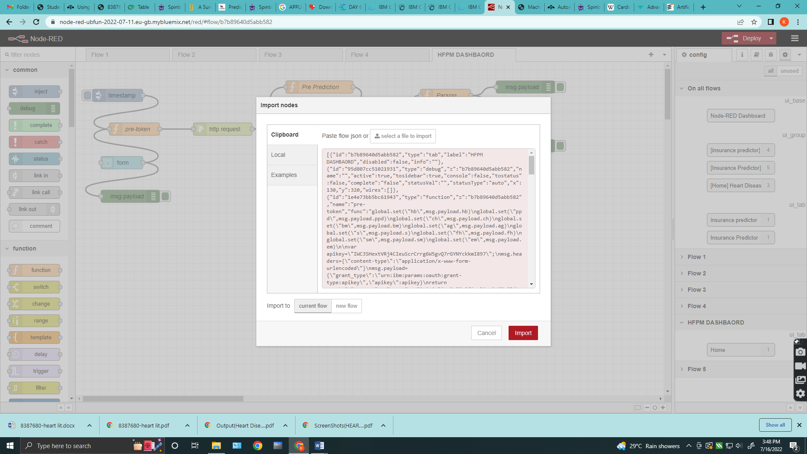

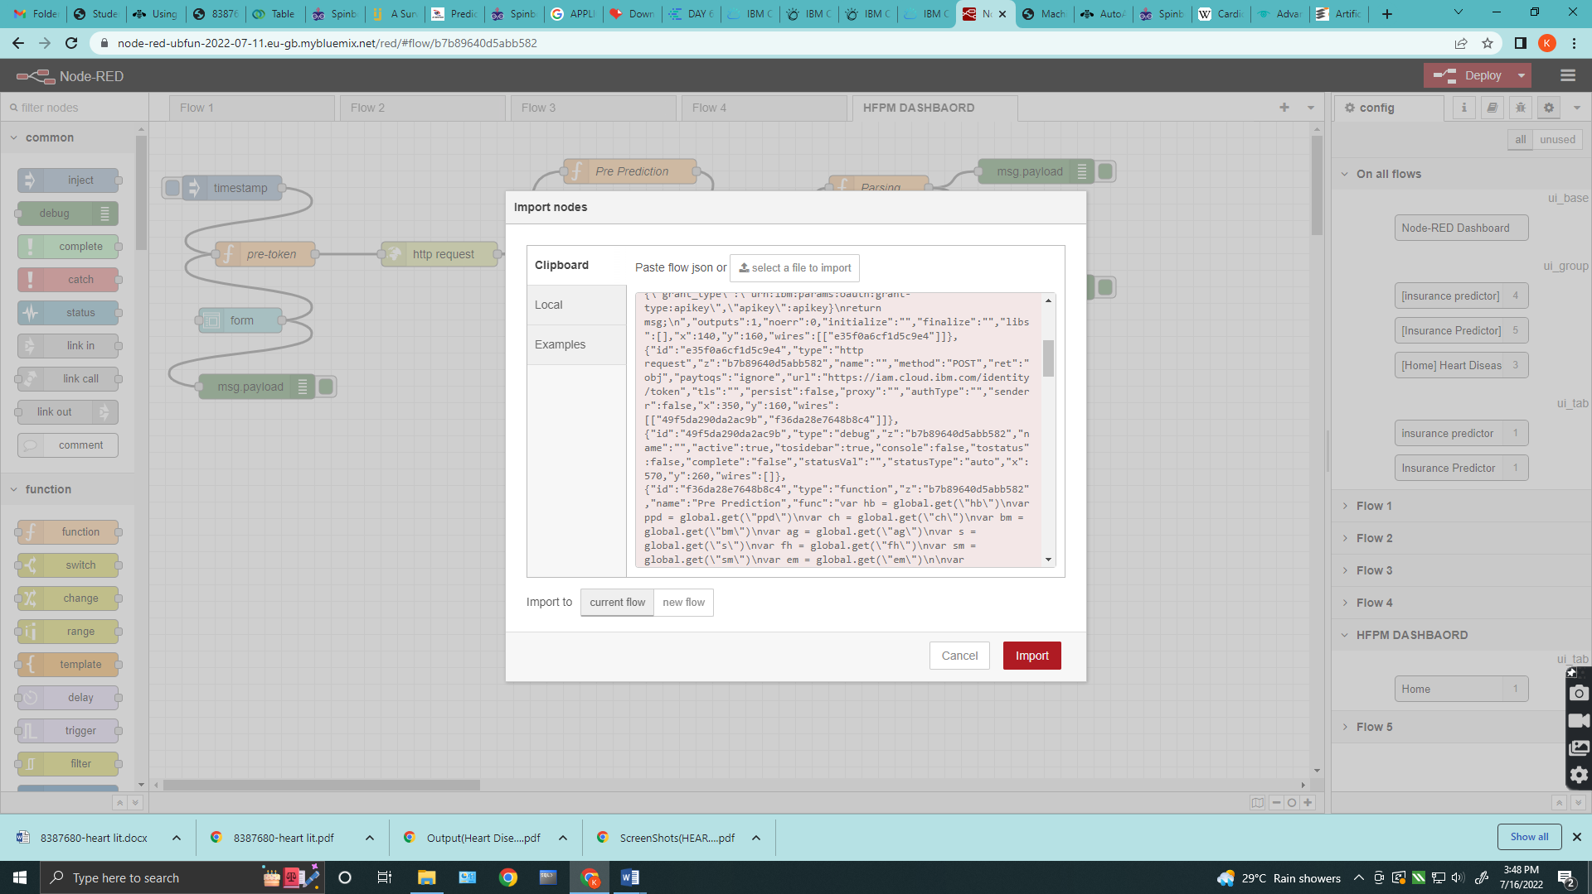

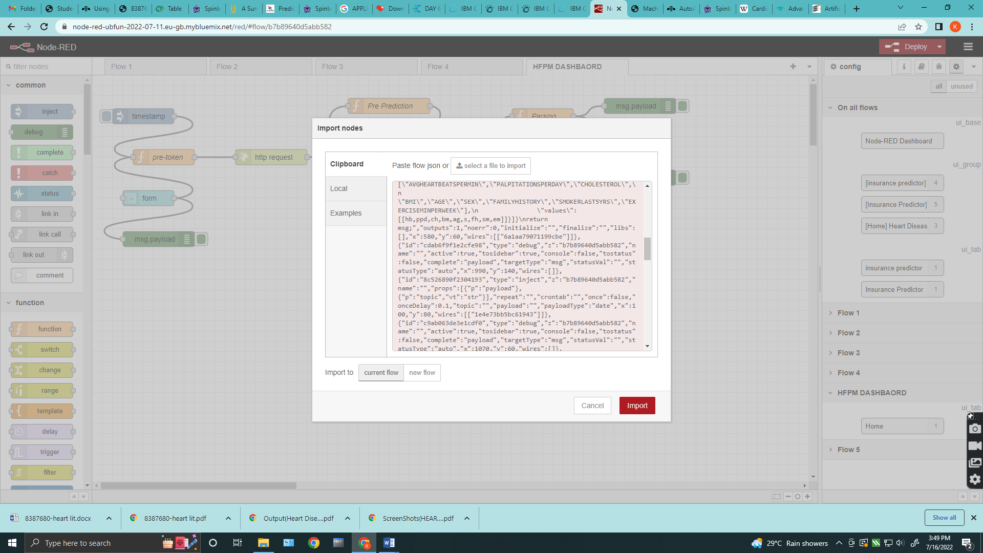

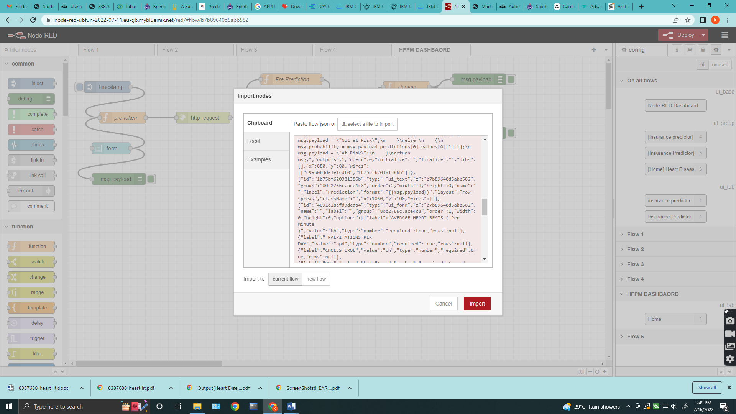

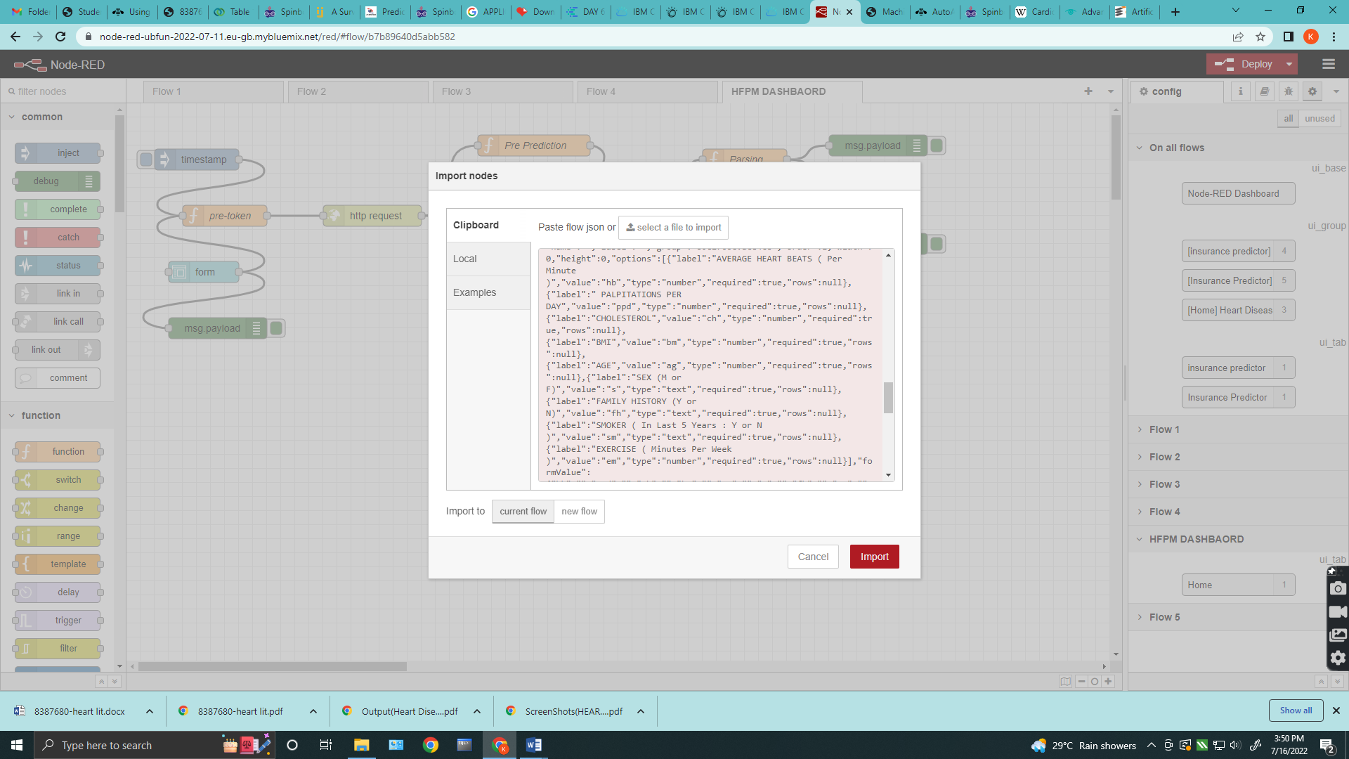

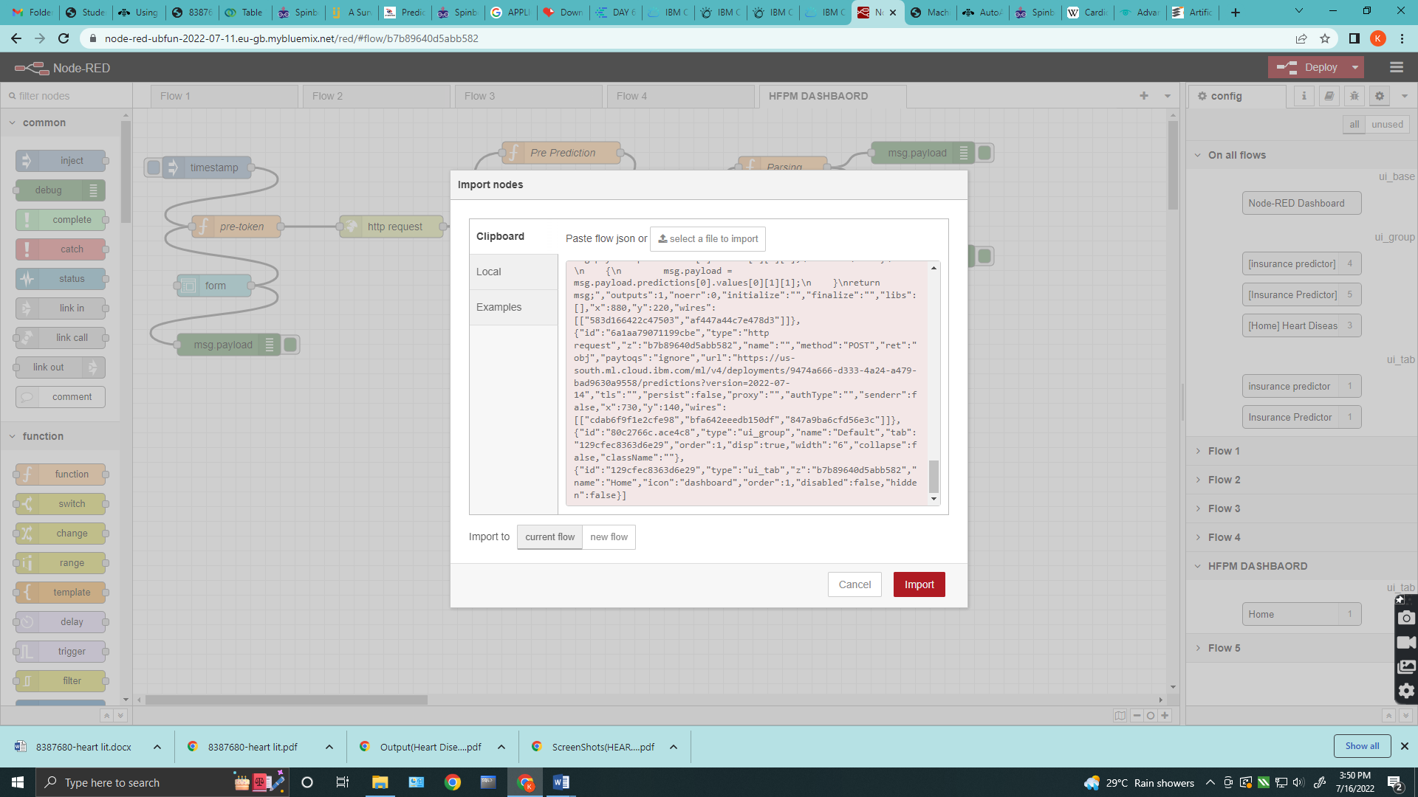

**OUTPUT SCREENSHOT**

